KRC data loggers metadata

TMS-4 loggers: Around our study sites, we installed 20 TMS-4 loggers (https://tomst.com/web/en/systems/tms/tms-4/). These loggers measure soil temperature every 15 minutes at a depth of -6, +2 and +15cm. They also measure electric conductivity of the soil, from which soil temperature can be calculated, using methods described here. We set up two loggers at each of the pitfall transect (BUGS project, see KRC pitfall trapping metadata), except for big dune (D15). One logger is located ca. 1 m east of the first and last pitfall base.
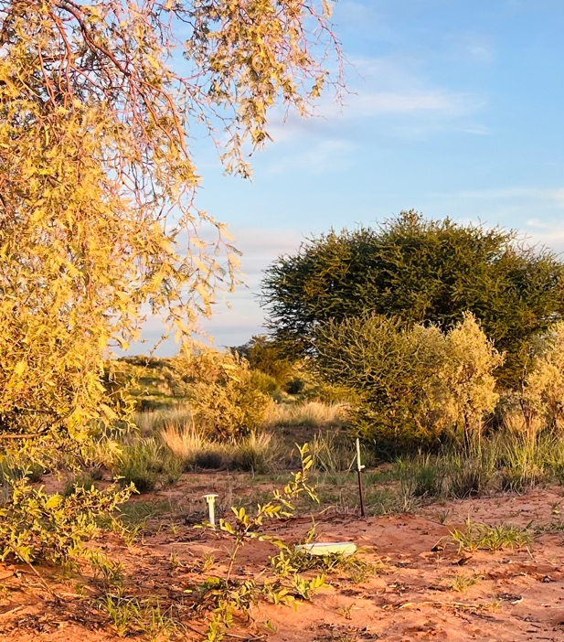

We also set up one logger in an OTC and another one just outside the OTC for the12 sites where we implemented the OTC experiments (see KRC OTC experiment metadata).

The OTCs are: JS4_OTC1; JS4_OTC2; JN4_OTC1; JN2_OTC3; KRR4_OTC (forgot to note which one); KRR1_OTC1

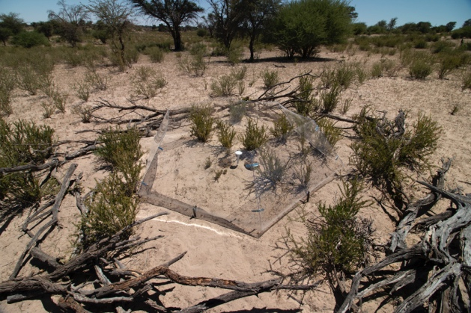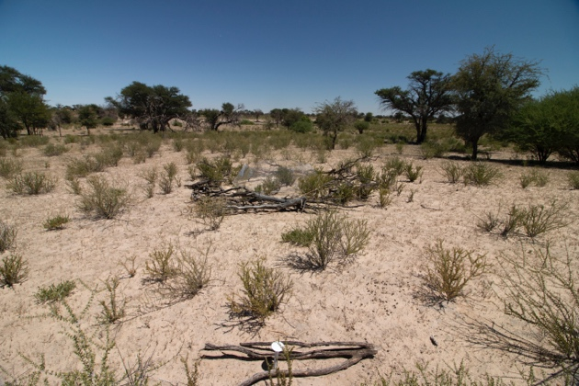

Lastly, we set up three buriable TMS loggers 0.5 m belowground next to the three deployed subterranean pitfall traps by base 5/6 in J13, J5, H15 (KRC pitfall trapping metadata).

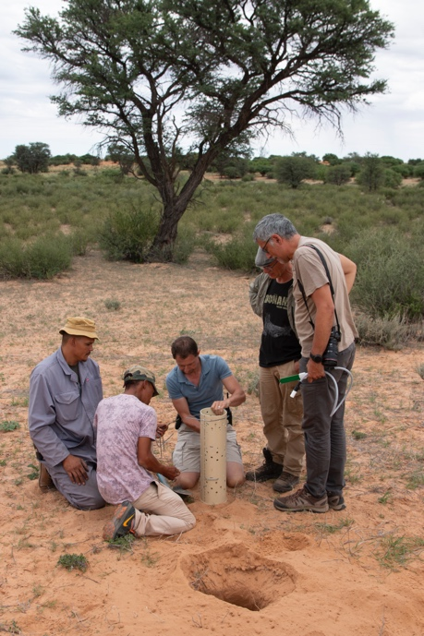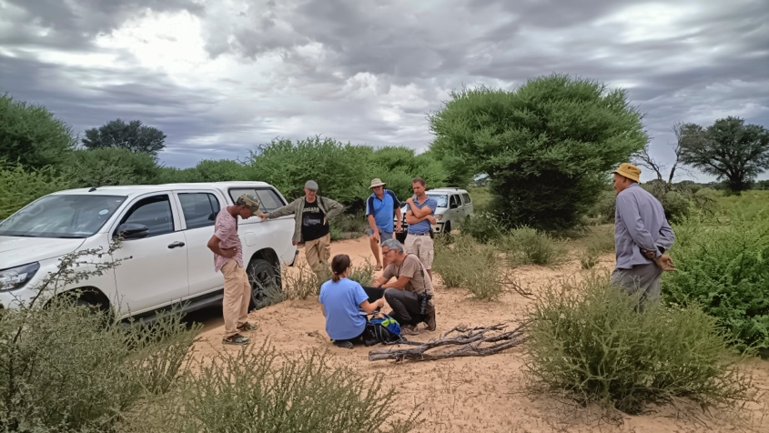

The ID of the loggers and deployment date and time are stored in logger_deployment.csv in the loggers subfolder.

Data collection: Data should be read out at every visit of a given site. To do so, the team’s laptop and the TMD adaptor (https://tomst.com/web/en/systems/tms/tms-4-accessories/) must be taken to the field. The data is collected as follows:

- Make sure the logger has not been altered by animal activity (for example digging). If it has (for instance, the green part is exposed), cover with soil and make a note of damage and the ID of the logger (on the side)
- Carefully remove the sunshield from the data logger without disturbing the logger in the soil
- Make sure the TMD adaptor the top of the datalogger (silver top with TOMST logo) have no sand on them
- On the laptop, open the Lolly software application
- Attach TMD adaptor to the laptop using the USB cord
- Attach the silver ring of the TMD adaptor to the top of the datalogger and hold it in place
- Look at the screen on Lolly application – you should track the data download.
- Detach the TMD adaptor when the download is finished.
- The data will be saved as “;” separated csv in Program Files x 64/Lolly (or something like that; the folder is indicated in the application). The data files are named: data_loggerID_year_month_day_0.csv
- Please copy the csv into the loggers/dataLolly sub-folder on one shared Dropbox folder.

For more info on the software, there is a “Lolly-software-Handbook.pdf” in our shared folder.

